**User module:**

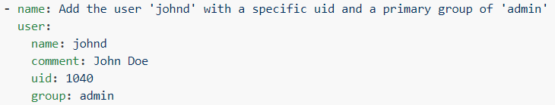

* Adding user with specific **“uid”** and **“group”**

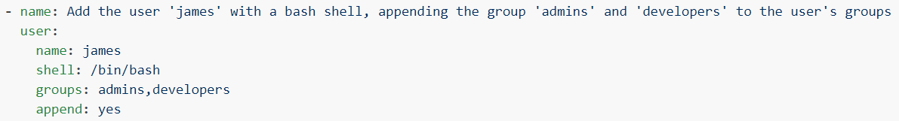

* Creating user with **“/bin/bash”** and adding into multiple groups.

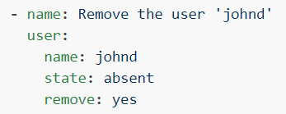

* Removing the user.

**Options:**

**force**

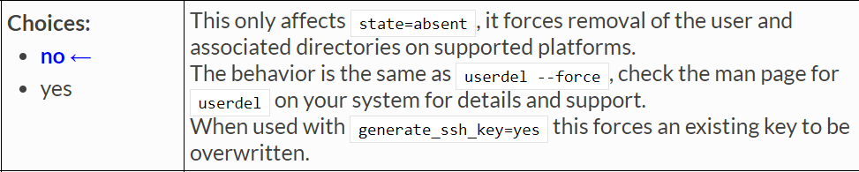

**group**



**password**

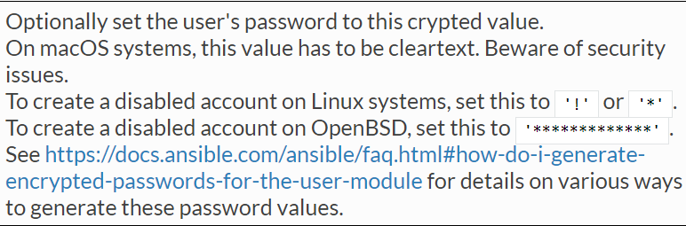

**state:**

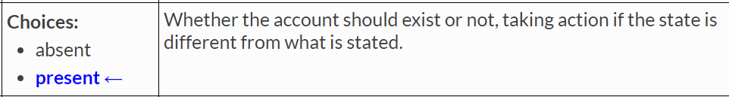

**remove**

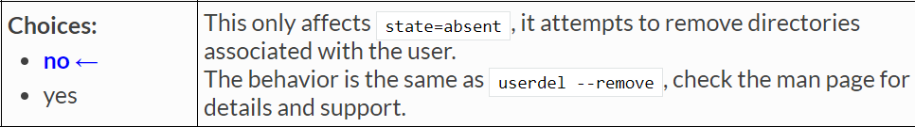

* **“state”** either creates or deletes the user. But **“remove”** cleans the user directories. This can be only associated with **“State”**

**create_home**

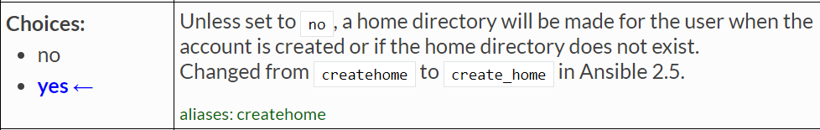

**Group module:**

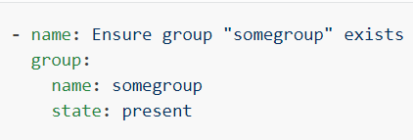

* To create the group as above.

**Options:**

**gid**

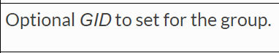

We can set gid to the group as above.

**name**



**state**

